I.INTRODUCTION
Distributed generation, also called on-site generation, dispersed generation, embedded generation, decentralized generation, decentralized energy, distributed energy or district energy,generates electricity from many small energy sources. Most countries generate electricity in large centralized facilities, such as fossil fuel (coal, gas powered),nuclear, large solar power plants or hydropower plants. These plants have excellent economies of scale, but usually transmit electricity long distances and can negatively affect the environment. Distributed generation allows collection of energy from many sources and may give lower environmental impacts and improved security of supply.
Distributed generation plants are mass-produced, small, and less site-specific. Their development arose out of:
- concerns over perceived externalized costs of central plant generation, particularly environmental concerns,
- the increasing age, deterioration, and capacity constraints upon T&D for bulk power,
- the increasing relative economy of mass production of smaller appliances over heavy manufacturing of larger units and on-site construction, and
- Along with higher relative prices for energy, higher overall complexity and total costs for regulatory oversight, tariff administration, and metering and billing.
Capital markets have come to realize that right-sized resources, for individual customers, distribution substations, or microgrids, are able to offer important but little-known economic advantages over Central Plants. Smaller units offered greater economies from mass-production than big ones could gain through unit size. These increased value—due to improvements in financial risk, engineering flexibility, security, and environmental quality—of these resources can often more than offset their apparent cost disadvantages. DG, vis-à-vis Central Plants, must be justified on a life-cycle basis. Unfortunately, many of the direct, and virtually all of the indirect, benefits of DG are not captured within traditional utility cash-flow accounting.
While the levelized generation cost of distributed generation is more expensive than conventional sources on a kWh basis, this does not consider negative aspects of conventional fuels. scale, innovation, competition, and moreflexiblefinancing, that could make DG clean energy part of a more diversified future.

Distributed generation reduces the amount of energy lost in transmitting electricity because the electricity is generated very near where it is used, perhaps even in the same building. This also reduces the size and number of power lines that must be constructed.
Typical distributed power sources in a feed-in tariff (FIT) scheme have low maintenance, low pollution and high efficiencies. In the past, these traits required dedicated operating engineers and large complex plants to reduce pollution. However, modern embedded systems can provide these traits with automated operation and renewables, such as sunlight, wind and
Grid parity has been reached in some locations with on-shore wind power around 2000, and with solar power it was achieved for the first time in Spain in 2013. Deutsche Bank says, that in January 2014 already more than 19 countries are under grid parity for solar power and sees starting a second gold rush for solar power.

Types of distributed energy resources
Distributed energy resource (DER) systems are small-scale power generation technologies (typically in the range of 1 kW to 10,000 kW) used to provide an alternative to or an enhancement of the traditional electric power system. The usual problem with distributed generators are their high initial capital costs
2. BRIEF DESCRIPTION ABOUT DG SOURCE ELEMENTS

2.1 Solar panel
A primary issue with solar power is that it is intermittent. Popular sources of power for distributed generation are solar heat collection panels andsolar panels on the roofs of buildings or free-standing.
Solar heating panels are used mostly for heating water and when the water is heated into steam it can effectively and economically be used in steam turbines to produce electricity.
The production cost for electricity produced from photovoltaic panels ranges from $0.99 to 2.00/W (2007) plus installation and supporting equipment unless the installation isDo it yourself (DIY) bringing the cost to $0.525 to 0.750/W (2010).
This is comparable to coal power plant costs of $0.582 to 0.906/W (1979 adjusting for inflation. Nuclear power is higher at $2.20 to $6.00/W (2007). Some "thin-film" solar cells have waste-disposal issues when they are made with heavy metals such as Cadmium telluride (CdTe) and Copper indium gallium selenide (CuInGaSe), and must be recycled, as opposed to silicon solar cells, which are mostly non-metallic.
Unlike coal and nuclear, there are no fuel costs, operating pollution, mining-safety or operating-safety issues. Solar power has a low capacity factor, producing peak power at local noon each day. Average capacity factor is typically 20%.
A solar panel (photovoltaic module or photovoltaic panel) is a packaged interconnected assembly of solar cells, also known as photovoltaic cells. The solar panel can be used as a component of a larger photovoltaic system to generate and supply electricity in commercial and residential applications.
Because a single solar panel can only produce a limited amount of power, many installations contain several panels. This is known as a photovoltaic array. A photovoltaic installation typically includes an array of solar panels, an inverter, batteries and interconnection wiring. Photovoltaic systems are used for either on- or off-grid applications, and on spacecraft.
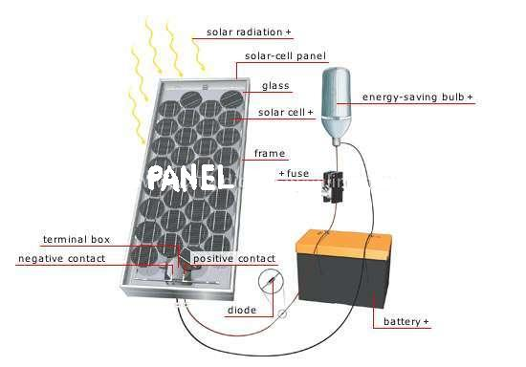
Fig2.1: Solar Panel System

2.1.1 Working:
Solar panels use light energy (photons) from the sun to generate electricity through the photovoltaic effect. The structural (load carrying) member of a module can either be the top layer (or the back layer (substrate). The majority of modules use wafer-based crystalline silicon cells or thin-film cells based on cadmium telluride or silicon.
Crystalline silicon is a commonly used semiconductor. In order to use the cells in practical applications, they must be: connected electrically to one another and to the rest of the system protected from mechanical damage during manufacture, transport, installation and use (in particular against hail impact, wind and snow loads).
This is especially important for wafer-based silicon cells which are brittle protected from moisture, which corrodes metal contacts and interconnections, and for thin-film cells the transparent conductive oxide layer, thus decreasing performance and lifetime.
Most solar panels are rigid, but semi-flexible ones are available, based on thin-film cells. Electrical connections are made in series to achieve a desired output voltage and/or in parallel to provide a desired amount of current source capability. Separate diodes may be needed to avoid reverse currents, in case of partial or total shading, and at night. The p-n junctions of mono-crystalline silicon cells may have adequate reverse current characteristics that these are not necessary.
Reverse currents are not only inefficient as they represent power losses, but they can also lead to problematic heating of shaded cells. Solar cells become less efficient at higher temperatures and so it desirable to minimize heat in the panels. Very few modules incorporate any design features to decrease temperature, but installers try to provide good ventilation behind solar panels.

2.2 fuel cells
A fuel cell is a device that converts the chemical energy from a fuel into electricity through a chemical reaction with oxygen or another oxidizing agent. Hydrogen is the most common fuel, but hydrocarbons such as natural gas and alcohols like methanol are sometimes used. Fuel cells are different from batteries in that they require a continuous source of fuel and oxygen/air to sustain the chemical reaction whereas in a battery the chemicals present in the battery react with each other to generate an emf. Fuel cells can produce electricity continuously for as long as these inputs are supplied.
The first fuel cells were invented in 1838. The first commercial use of fuel cells came more than a century later inNASA space programs to generate power for probes, satellites and space capsules. Since then, fuel cells have been used in many other applications. Fuel cells are used for primary and backup power for commercial, industrial and residential buildings and in remote or inaccessible areas. They are also used to power fuel-cell vehicles, including forklifts, automobiles, buses, airplanes, boats, motorcycles and submarines.
There are many types of fuel cells, but they all consist of an anode, a cathode and an electrolyte that allows charges to move between the two sides of the fuel cell. Electrons are drawn from the anode to the cathode through an external circuit, producing direct current electricity. As the main difference among fuel cell types is the electrolyte, fuel cells are classified by the type of electrolyte they use followed by the difference in startup time ranging from 1 sec for PEMFC to 10 min for SOFC. Fuel cells come in a variety of sizes.
Individual fuel cells produce relatively small electrical potentials, about 0.7 volts, so cells are "stacked", or placed in series, to increase the voltage and meet an application's requirements. In addition to electricity, fuel cells produce water, heat and, depending on the fuel source, very small amounts of nitrogen dioxide and other emissions. The energy efficiency of a fuel cell is generally between 40–60%, or up to 85% efficient in cogeneration if waste heat is captured for use.
The fuel cell market is growing, and Pike Research has estimated that the stationary fuel cell market will reach 50 GW by 2020.

2.2.1 Types of fuel cells; design
Fuel cells come in many varieties; however, they all work in the same general manner. They are made up of three adjacent segments: theanode, the electrolyte, and the cathode. Two chemical reactions occur at the interfaces of the three different segments. The net result of the two reactions is that fuel is consumed, water or carbon dioxide is created, and an electric current is created, which can be used to power electrical devices, normally referred to as the load.
At the anode a catalyst oxidizes the fuel, usually hydrogen, turning the fuel into a positively charged ion and a negatively charged electron. The electrolyte is a substance specifically designed so ions can pass through it, but the electrons cannot. The freed electrons travel through a wire creating the electric current. The ions travel through the electrolyte to the cathode. Once reaching the cathode, the ions are reunited with the electrons and the two react with a third chemical, usually oxygen, to create water or carbon dioxide.
The most important design features in a fuel cell are]:
The electrolyte substance. The electrolyte substance usually defines the type of fuel cell.
The fuel that is used. The most common fuel is hydrogen.
The anode catalyst breaks down the fuel into electrons and ions. The anode catalyst is usually made up of very fine platinum powder.
The cathode catalyst turns the ions into the waste chemicals like water or carbon dioxide. The cathode catalyst is often made up of nickel but it can also be a nanomaterial-based catalyst.
A typical fuel cell produces a voltage from 0.6 V to 0.7 V at full rated load. Voltage decreases as current increases, due to several factors:
Activation losses
Ohmic loss (voltage drop due to resistance of the cell components and interconnections)
Mass transport loss (depletion of reactants at catalyst sites under high loads, causing rapid loss of voltage)
To deliver the desired amount of energy, the fuel cells can be combined in series and parallel circuits to yield higher voltage, and parallel-channel of configurations allow a higher current to be supplied. Such a design is called a fuel cell stack. The cell surface area can be increased, to allow stronger current fromeach cell. In the stack, reactant gases must be distributed uniformly over all of the cells to maximize the power output.
2.2.2 APPLICATIONS FUEL CELLS
Power
Stationary fuel cells are used for commercial, industrial and residential primary and backup power generation. Fuel cells are very useful as power sources in remote locations, such as spacecraft, remote weather stations, large parks, communications centers, rural locations including research stations, and in certain military applications.
A fuel cell system running on hydrogen can be compact and lightweight, and have no major moving parts. Because fuel cells have no moving parts and do not involve combustion, in ideal conditions they can achieve up to 99.9999% reliability. This equates to less than one minute of downtime in a six-year period
Since fuel cell electrolyzer systems do not store fuel in themselves, but rather rely on external storage units, they can be successfully applied in large-scale energy storage, rural areas being one example. There are many different types of stationary fuel cells so efficiencies vary, but most are between 40% and 60% energy efficient. However, when the fuel cell's waste heat is used to heat a building in a cogeneration system this efficiency can increase to 85%. This is significantly more efficient than traditional coal power plants, which are only about one third energy efficient.

Assuming production at scale, fuel cells could save 20–40% on energy costs when used in cogeneration systems. Fuel cells are also much cleaner than traditional power generation; a fuel cell power plant using natural gas as a hydrogen source would create less than one ounce of pollution (other than CO₂) for every 1,000 kW·h produced, compared to 25 pounds of pollutants generated by conventional combustion systems. Fuel Cells also produce 97% less nitrogen oxide emissions than conventional coal-fired power plants.
Coca-Cola, Google, Walmart, Sysco, FedEx, UPS, Staples, Whole Foods, Gills Onions, Nestle Waters, Pepperidge Farm, Sierra Nevada Brewery, Super Store Industries, Brigestone-Firestone, Nissan North America, Kimberly-Clark, Michelin and more have installed fuel cells to help meet their power needs. One such pilot program is operating on Stuart Island in Washington State. There the Stuart Island Energy Initiativehas built a complete, closed-loop system: Solar panels power an electrolyzer, which makes hydrogen. The hydrogen is stored in a 500-U.S.-gallon (1,900 L) tank at 200 pounds per square inch (1,400 kPa), and runs a ReliOn fuel cell to provide full electric back-up to the off-the-grid residence. Another closed system loop was unveiled in late 2011 in Hempstead, NY.
Fuel cells can be used with low-quality gas from landfills or waste-water treatment plants to generate power and lower methane emissions. A 2.8 MW fuel cell plant in California is said to be the largest of the type.

2.3 Wind turbine
Another source is small wind turbines. These have low maintenance, and low pollution, however as with solar, wind energy is intermittent. Construction costs are higher ($0.80/W, 2007) per watt than large power plants, except in very windy areas.
Wind towers and generators have substantial insurable liabilities caused by high winds, but good operating safety. In some areas of the US there may also be Property Tax costs involved with wind turbines that are not offset by incentives or accelerated depreciation.
Wind also tends to complement solar. Days without sun there tend to be windy, and vice versa] Many distributed generation sites combine wind power and solar power such as Slippery Rock University, which can be monitored online.

2.4 PHOTOVOLTAIC SYSTEM

2.4.1 Photovoltaic Effect:
Photovoltaic (PV) is a method of generating electrical power by converting solar radiation into direct current electricity using semiconductors that exhibit the photovoltaic effect. Photovoltaic power generation employs solar panels comprising a number of cells containing a photovoltaic material. Materials presently used for photovoltaic include mono crystalline silicon, polycrystalline silicon, amorphous silicon, cadmium telluride, and copper indium selenide/sulfide. Due to the growing demand for renewable energy sources, the manufacturing of solar cells and photovoltaic arrays has advanced considerably in recent years.
As of 2010, solar photovoltaic generates electricity in more than 100 countries and, while yet comprising a tiny fraction of the 4800 GW total global power-generating capacity from all sources, is the fastest growing power-generation technology in the world.
Between 2004 and 2009, Grid-connected PV capacity increased at an annual average rate of 60 percent, to some 21 GW. Such installations may be ground-mounted (and sometimes integrated with farming and grazing) or built into the roof or walls of a building, known as Building Integrated Photovoltaic’s or BIPV for short. Off-grid PV accounts for an additional 3–4 GW.
Driven by advances in technology and increases in manufacturing scale and sophistication, the cost of photovoltaic has declined steadily since the first solar cells were manufactured. Net metering and financial incentives, such as preferential feed-in tariffs for solar-generated electricity; have supported solar PV installations in many countries.
The photovoltaic effect is the generation of a voltage (or a corresponding electric current) in a material upon exposure to light. Though the photovoltaic effect is directly related to the photoelectric effect, the two processes are different and should be distinguished. In the photoelectric effect, electrons are ejected from a material's surface upon exposure to radiation of sufficient energy. The photovoltaic effect is different in that the generated electrons are transferred between different bands (i.e. from the valence to conduction bands) within the material, resulting in the buildup of a voltage between two electrodes. In most photovoltaic applications the radiation is sunlight and for this reason the devices are known as solar cells. In the case of a p-n junction solar cell, illumination of the material results in the generation of an electric current as excited electrons and the remaining holes are swept in different directions by the built-in electric field of the depletion region. The photovoltaic effect was first observed by Alexandre-Edmond Becquerel in 1839.
Fig 2.4.1: PV effect converts the photon energy into voltage across the pn junction
As of October 2010, the largest photovoltaic (PV) power plants in the world are the Sarnia Photovoltaic Power Plant (Canada, 80 MW), the Olmedilla Photovoltaic Park (Spain, 60 MW), the Strasskirchen Solar Park (Germany, 54 MW), the Lieberose Photovoltaic Park (Germany, 53 MW), the Puertollano Photovoltaic Park (Spain, 50 MW), the Moura photovoltaic power station (Portugal, 46 MW), and the Waldpolenz Solar Park (Germany, 40 MW).

2.4.2 Applications of photo voltaic system:
- In Buildings
Photovoltaic arrays are often associated with buildings: either integrated into them, mounted on them or mounted nearby on the ground.
Arrays are most often retrofitted into existing buildings, usually mounted on top of the existing roof structure or on the existing walls. Alternatively, an array can be located separately from the building but connected by cable to supply power for the building. In 2010, more than four-fifths of the 9,000 MW of solar PV operating in Germany was installed on rooftops.
- In Transport
PV has traditionally been used for electric power in space. PV is rarely used to provide motive power in transport applications, but is being used increasingly to provide auxiliary power in boats and cars. A self-contained solar vehicle would have limited power and low utility, but a solar-charged vehicle would allow use of solar power for transportation. Solar-powered cars have been demonstrated.
- Standalone Devices:
Until a decade or so ago, PV was used frequently to power calculators and novelty devices. Improvements in integrated circuits and low power LCD displays make it possible to power such devices for several years between battery changes, making PV use less common. In contrast, solar powered remote fixed devices have seen increasing use recently in locations where significant connection cost makes grid power prohibitively expensive. Such applications include water pumps, parking meters, emergency telephones, trash compactors, temporary traffic signs, and remote guard posts & signals.
- Rural Electrification
Developing countries where many villages are often more than five kilometers away from grid power have begun using photovoltaic. In remote locations in India a rural lighting program has been providing solar powered LED lighting to replace kerosene lamps. The solar powered lamps were sold at about the cost of a few months’ supply of kerosene. Cuba is working to provide solar power for areas that are off grid. These are areas where the social costs and benefits offer an excellent case for going solar though the lack of profitability could relegate such endeavors to humanitarian goals.
- Solar roadways
A 45 mi (72 km) section of roadway in Idaho is being used to test the possibility of installing solar panels into the road surface, as roads are generally unobstructed to the sun and represent about the percentage of land area needed to replace other energy sources with solar power.
- Solar Power Satellites
Design studies of large solar power collection satellites have been conducted for decades. The idea was first proposed by Peter Glaser, then of Arthur D. Little Inc; NASA conducted a long series of engineering and economic feasibility studies in the 1970s, and interest has revived in first years of the 21st century. From a practical economic viewpoint, the key issue for such satellites appears to be the launch cost. Additional considerations will include developing space based assembly techniques, but they seem to be less a hurdle than the capital cost. These will be reduced as photovoltaic cell costs are reduced or alternatively efficiency increased.

2.4.3 Performance:
- Temperature
Generally, temperatures above room temperature reduce the performance of photovoltaic.
- Optimum Orientation of Solar Panels
For best performance, terrestrial PV systems aim to maximize the time they face the sun. Solar trackers aim to achieve this by moving PV panels to follow the sun. The increase can be by as much as 20% in winter and by as much as 50% in summer. Static mounted systems can be optimized by analysis of the Sun path. Panels are often set to latitude tilt, an angle equal to the latitude, but performance can be improved by adjusting the angle for summer or winter.
- Irradiation:
Irradiation is the process by which an item is exposed to radiation. The exposure can be intentional, sometimes to serve a specific purpose, or it can be accidental. In common usage the term refers specifically to ionizing radiation, and to a level of radiation that will serve that specific purpose, rather than radiation exposure to normal levels of background radiation or abnormal levels of radiation due to accidental exposure. This term also applies to 'non-ionizing radiation as microwaves or to low frequency (50/60 Hz power supply), high frequency (as cellular phones, radio and TV transmissions).
- Insolation:
Insolation is a measure of solar radiation energy received on a given surface area in a given time. It is commonly expressed as average irradiance in watts per square meter (W/m2) or kilowatt-hours per square meter per day (kW·h/(m²·day)) (or hours/day). In the case of photovoltaics it is commonly measured as kWh/(year/KW) (kilowatt hours per year per kilowatt peak rating).
The given surface may be a planet, or a terrestrial object inside the atmosphere of a planet, or any object exposed to solar rays outside of an atmosphere, including spacecraft. Some of the solar radiation will be absorbed while the remainder will be reflected. Most commonly, the absorbed solar radiation causes radiant heating, however, some systems may store or convert some portion of the absorbed radiation, as in the case of photovoltaics or plants. The proportion of radiation reflected or absorbed depends on the object's reflectivity or albedo, respectively.

2.4.4 Solar Cell
A solar cell is a solid state device that converts the energy of sunlight directly into electricity by the photovoltaic effect. Assemblies of cells are used to make solar modules, also known as solar panels. The energy generated from these solar modules, referred to as solar power, is an example of solar energy.
The origin of the PV potential is the difference in the chemical potential, called the Fermi level, of the electrons in the two isolated materials. When they are joined, the junction approaches a new thermodynamic equilibrium. Such equilibrium can be achieved only when the Fermi level is equal in the two materials. This occurs by the flow of electrons from one material to the other until a voltage difference is established between them, which have a potential just equal to the initial difference of the Fermi level. This potential drives the photocurrent in the PV circuit.
Photovoltaics is the field of technology and research related to the practical application of photovoltaic cells in producing electricity from light, though it is often used specifically to refer to the generation of electricity from sunlight.
Cells are described as photovoltaic cells when the light source is not necessarily sunlight. These are used for detecting light or other electromagnetic radiation near the visible range, for example infrared detectors), or measurement of light intensity.
Fig 2.4.4: Basic construction of PV cell
The diagram above illustrates the operation of a basic photovoltaic cell, also called a solar cell. Solar cells are made of the same kinds of semiconductor materials used in microelectronics, such as silicon (melted sand) or cadmium telluride. For solar cells, a thin semiconductor wafer is specially treated to form an electric field, positive on one side and negative on the other. When light energy strikes the solar cell, electrons are knocked loose from the atoms in the semiconductor material. If electrical conductors are attached to the positive and negative sides, forming an electrical circuit, the electrons can be captured in the form of an electric current. This electricity can then be used to power a load, such as a light or a tool. Each PV cell converts about 5 to 15 percent of the sunlight that hits it into electrical current. Photovoltaic cells are modular. That is, one can be used to make a very small amount of electricity, or many can be used together to make a large amount of electricity.
Photovoltaic cell produces only about one-half volt of electricity, cells are often mounted together in groups called modules. Each module holds about forty photovoltaic cells. By being put into modules, the current from a number of cells can be combined. PV cells can be strung together in a series of modules or strung together in a parallel placement to increase the electrical output
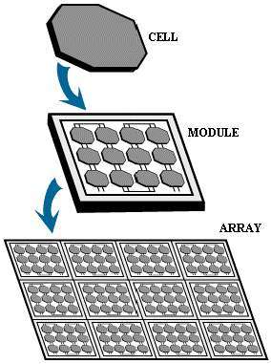

Fig2. 4.5: Thepv array set up
When multiple PV cell modules are put together, they can form an arrangement called an array or array field. In general, the larger the area of a module or array, the more electricity that will be produced. Photovoltaic modules and arrays produce direct current (dc) electricity. They can be connected in both series and parallel electrical arrangements to produce any required voltage and current combination.

2.4.5 Types Of Photovoltaic Cells:
A monocrystalline PV cell is blue or gray-black in color. At the rounded corner of each cell is a white backing. This backing shows through and makes a pattern that is easy to see. Some people do not use monocrystalline PV cells on their home or businesses because of their appearance. A module of PV cells is usually covered with tempered glass and surrounded by an aluminum frame.
A polycrystalline PV cell looks a little different than a monocrystalline PV cell. Polycrystalline PV cells are shaped like rectangles and colored sparkling blue. There is no white background showing. Thus, these PV cells look more uniform in appearance. Like monocrystalline cells, they are often covered in tempered glass and placed in an aluminum frame.
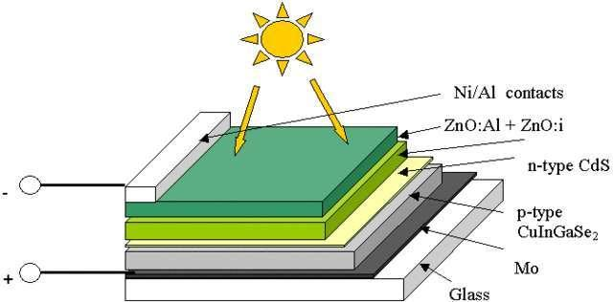

Fig2.4.6 Structure of a model Solar Cell

Another type is the amorphous or thin-film cell. This type of PV cell is less durable and not as efficient for energy conversion. Thin-film cells are the future of PV cell technology because they use less semiconductor material, do not need as much energy to manufacture, and are easier to mass produce than other PV cells. Light weight and flexible, this technology can be weaved into the fabric of a building in applications where surface area is not an issue. Applications include building canopies, facades and rain screens.Solar panels use light energy (photons) from the sun to generate electricity through the photovoltaic effect. The structural (load carrying) member of a module can either be the top layer (or the back layer (substrate). The majority of modules use wafer-based crystalline silicon cells or thin-film cells based on cadmium telluride or silicon.
Fig2. 4.7: Construction of PV module: (1) frame, (2) weatherproof junction box, (3) rating
plate, (4) weather protection for 30-yr life, (5) PV cell, (6) tempered high-transmittivity cover glass, (7) outside electrical bus, (8) frame clearance. (From Solarex/BP Solar, Frederick, MD.

2.4.8 Main Operation:
Solar cell works in three steps:
Photons in sunlight hit the solar panel and are absorbed by semiconducting materials, such as silicon.
Electrons (negatively charged) are knocked loose from their atoms, allowing them to flow through the material to produce electricity. Due to the special composition of solar cells, the electrons are only allowed to move in a single direction.
An array of solar cells converts solar energy into a usable amount of direct current (DC) electricity.

2.4.8.1 Equivalent Circuit:
Fig2.4.8:PV cell equivalent circuit
The complex physics of the PV cell can be represented by the equivalent electrical circuit. The circuit parameters are as follows. The current Iat the output terminals is equal to the light-generated current I_{L}, less the diode current I_{d} and the shunt-leakage current I_{sh}. The series resistance R_{s} represents the internal resistance to the current flow, and depends on the pn junction depth, impurities, and contact resistance. The shunt resistance R_{sh} is inversely related to the leakage currentto ground. In an ideal PV cell, R_{s} = 0Ω (no series loss), and R_{sh}=∞(no leakage to ground). In a typical high-quality 1 in.2 silicon cell, Rs varies from 0.05 to 0.10 Ω and R_{sh} from 200 to 300 Ω. The PV conversion efficiency is sensitive to small variations in Rs, but is insensitive to variations in R_{sh}. A small increase in Rs can decrease the PV output significantly. In the equivalent circuit, the current delivered to the external load equals the current I_{L} generated by the illumination, less the diode current Id and the shunt leakage current I_{sh}. The open-circuit voltage Voc of the cell is obtained when the load current is zero, i.e., when I = 0, and is given by the following:
V_{oc}=V+IR_{sh}
The shunt resistance (R_{sh}) is very large and the series resistance (Rs) is very small. Therefore, it is common to neglect these resistances in order to simplify the solar cell model. The resultant ideal voltage-current characteristic of a photovoltaic cell is given by the relation below and illustrated by the figure above.
I=I_{ph}-I_{D}
I=I_{ph}-I₀$\left[exp\left(\frac{q\left(V+R_{s}I\right)}{Ak_{B}T}\right)-1\right]-\frac{V+R_{s}I}{R_{sh}}$
Where,
I_{ph} = photocurrent,
I_{D} = diode current,
I₀ = saturation current,
A = ideality factor,
q = electronic charge 1.6x10⁻⁹,
k_{B} = Boltzmann’s gas constant (1.38x10⁻²³),
T = cell temperature,
R_{s} = series resistance,
R_{sh} = shunt resistance,
I = cell current,
I_{ph} = photocurrent,
I_{D} = diode current,
I₀ = saturation current,
A = ideality factor,
q = electronic charge 1.6x10⁻⁹,
k_{B} = Boltzmann’s gas constant (1.38x10⁻²³),
T = cell temperature,
R_{s} = series resistance,
R_{sh} = shunt resistance,
I = cell current,
The power output of a solar cell is given by
P_{PV} = V_{PV} * I_{PV}
Where,
I_{PV} = Output current of solar cell (A).
V_{PV} = Solar cell operating voltage (V).
P_{PV} =Output power of solar cell (W).
The power-voltage (P-V) characteristic of a photovoltaic module operating at a standard irradiance of 1000 W/m² and temperature of 25ºC is shown below.
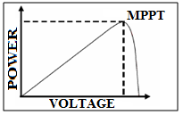
Fig2. 4.9: Power-Voltage (PV) Characteristic of a Photovoltaic Module.
It can be seen from the characteristics, that there is a unique point on the characteristics at which the photovoltaic power is maximum. This point is termed as the maximum power point (MPP). The power corresponding to this point is termed as power at maximum power point (P_{mpp}) and the voltage as voltage at maximum power point (V_{mpp}). Due to high cost of solar cells, it must be ensured that the photovoltaic array operates at all time to provide maximum power output. Hence a maximum power point tracker must be used to track the maximum power of the system. This is commonly known as maximum power point tracking (MPPT). Now if the irradiance level of the photovoltaic system is changed from the standard 1000 W/m² to say 600 W/m² or 400 W/m² then the P-V characteristic will change as shown in the figure below.
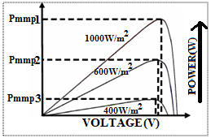

Fig2.5: Variation of P-V Characteristics of Photovoltaic Module
The above graph shows that, the maximum power of the PV system also reduces accordingly. The maximum power point tracker must now track the new maximum power point for the changed irradiance level.

3. BUCK-BOOST CONVERTER
3 Classification of choppers
A chopper circuit is used to refer to numerous types of electronic switching devices and circuits. The term has become somewhat ill-defined, and as a result is much less used nowadays than it was perhaps 30 or more years ago.
A chopper is a static device that converts fixed dc input to a variable dc output voltage directly. A chopper may be thought of as an ac transformer since they behave in an identical manner.
Essentially, a chopper is an electronicswitchthat is used to interrupt one signal under the control of another. Choppers may be classified on several bases.
1.On basis of I/P-O/p voltage levels: i Step-down chopper
ii. Step-up chopper
2. On basis of direction of output voltage and current: i. Class A
ii. Class B
iii. Class C
iv. Class D
v. Class E

3. On basis of circuit operation:i. First quadrant
ii. Two quadrant
iii. Four quadrant
4. On basis of commutation method:
i. Voltage commutated
ii. Current commutated
iii. Load commutated
iv. Impulse commutated

3.1Principle Of STEP_DOWN Chopper
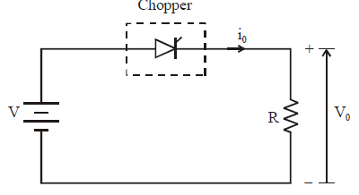
Fig. 3.1.1: Step‐down Chopper with Resistive Load

The thyristor in the circuit acts as a switch. When thyristor is ON,supply voltage appearsacross the load and when thyristor is OFF, the voltage across the load will be zero. The output voltage andcurrent waveforms are as shown in figure 3.2.

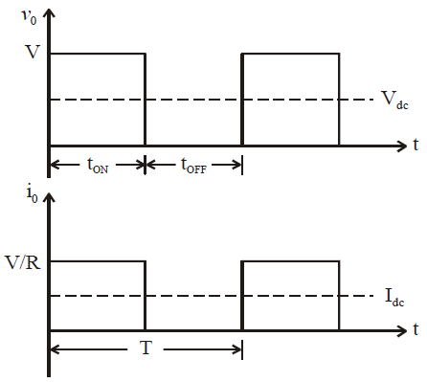

Fig. 3.1.2: Step-down choppers — output voltage and current waveforms

3.1.2 Expression For Output Voltage
V_{dc}=average value of output or load voltage
I_{dc}=average value of output or load current
t_{ON}=time for which SCR is ON
t_{OFF} time interval for which SCR is OFF
T=t_{ON}+t_{OFF}=period of switching or chopping period
f=1/T=frequency pf chopper switching or chopper frequency
Average output voltage
V_{dc}=V(t_{on}/t_{on}+t_{off})
V_{dc}=V(tON/T)=Vd
But (t_{ON}/T)=d=duty cycle
Average output current
Idc=Vdc/Rdc
Idc=(v/r)d
RMS value of output voltage
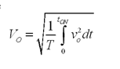
But during T_{on} vo=V
There fore RMSoutput voltage Vo=
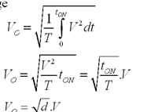
Output power P_{o}=V_{o}I_{o}
But Io=Vo/RTherefore P_{o}=V_{o}²/R
P_{o}=dV²/R
Effective input resistance R_{i}=V/I_{dc}
R_{i}=R/d
The output voltage can be varied by varying duty cycle

3.2 Principle Of STEP UP Chopper

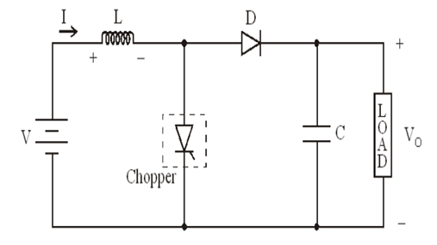
Fig.3.2.1Step up chopper
Figure 3.3 shows a step-up chopper to obtain a load voltage Vohigher than the input voltage V.The values of L and C are chosen depending upon the requirement of output voltage and current .When the chopper is ON, the inductor L is connected across the supply.The inductor current I rises and the inductor stores energy during the ON time of the chopper,I_{ON.}When the chopper is off ,the inductor current I is forced to flow through the diode D and load for a period ,t_{OFF .}The current tends to decrease resulting in reversing the polarity of induced EMF in L.Therefore voltage across load is given by
V_{o}=V+Ldi/dt i.e., V_{o}>V
3.2.2 Expression For Output Voltage
Assume the average inductor current to be I during ON and OFF time of the chopper
When chopper is on
Voltage across inductor L=V
Therefore energy stored in inductor = V.I.t_{ON}
Where T_{ON} =ON period of chopper
When Chopper is OFF (energy is supplied by inductor to load)
Voltage across L=(V_{o-}V)It_{OFF} ,Where t_{OFF} =OFF period of chopper.
Neglecting losses,energy stored in inductor L=energy supplied by inductor L
Therefore VIt_{ON} =(V_{o-}V)It_{OFF}
V_{o}=V[T_{ON}+T_{OFF}]/T_{OFF}
V_{o}=V(T/T-t_{ON})
Where T=Chopping period or period of switching
T=t_{On}+t_{OFF}

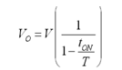
Therefore Vo=V(1/1-d) …(2.29)
Where d=t_{ON}/T =duty cycle.
For variation of duty cycle ‘d’ in the range of 0<d<1,the output voltage V_{o} will vary in the range V<Vo<infinity

3.2.3 Circuit diagram

Fig3.2.3: Buck-boost converter circuit diagram
3. 2.4 Operation

The buck-boost converter is a dc-dc converter that has output voltage magnitude which is either above or below the input voltage magnitude .it is a switched mode power supply with similar circuit topology to the buck converter and boost converter.
The output voltage is adjusted based on the duty cycle of switched transistors. one drawback of this converter has the switch does not have terminal at ground. This complicates the driving circuitary The output voltage is opposite polarity to the input voltage.

Operation of the buck-boost converter can be explained in two modes.
Mode1: when source voltage is applied to the mosfet in forward bias condition then it acts as switch and flow of current takes place through it This current is flowing through Inductor
During this condition diode is in reverse bias condition .then it acts as open circuit.
Mode2:During reverse bias condition the stored energy in inductor is flowing through capacitor and load..This process is continue until the energy stored in inductor is completed.
3.3.1 Waveforms
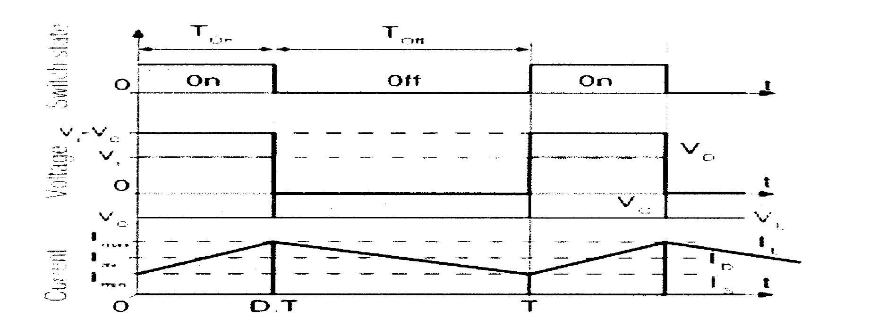
Fig3.2.4 current and voltage waveforms of buck-boost converter

- INVERTERS

4.1Classification of Inverters
Inverters can be classified on the basis of a number of factors:
- Classification according to the Nature of Input Source
- Voltage Source Inverters(VSI)
- Current Source Inverters(CSI)
In case of VSI, the input to the inverter is provided by a ripple free dc voltage source and the dc source has small or negligible impedance.Because of low internal impedance, the terminal of a voltage source inverter remains substantially constant with variations in load.Any short circuit across its terminals causes current to rise fast, due to low time constant of its internal impedance. It is therefore, equally suitable for single and multi- motor drives.
On the other hand, CSI is supplied with a controlled current from a D.C. source of high impedance. Typically, a phase controller rectifier feeds the inverter with a regulated current through a large series inductor. Thus, load current rather than load voltage is controlled, and the inverter output voltage is dependent upon the load impedance. Because of a large internal impedance, the terminal voltage of a current source inverter changes substantially with a change in load. Therefore it is not suitable for single and multi-motor drives.
(b)Classification according to the Wave shape of the Output voltage
- Square-wave Inverter
- Pulse-width modulated(PWM) Inverter
A square-wave inverter produces a square ac voltage of a constant magnitude The output voltage of this type of inverter can only be varied by controlling the input dc voltage quare-wave ac output voltage of an inverter is adequate for low and medium power applications. The second method, pulse width modulation (PWM) uses a switching scheme within the inverter to modify the shape of the output voltage waveform.
4.2.1 H-Bridge Inverters
An H bridge is an electronic circuit that enables a voltage to be applied across a load in either direction. These circuits are often used in robotics and other applications to allow DC motors to run forwards and backwards.
The term H bridge is derived from the typical graphical representation of such a circuit. An H bridge is built with four switches (solid-state or mechanical).
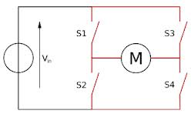
Fig.4.2.1 Block diagram of H-bridge Inverter.
When the switches S1 and S4 (according to the first figure) are closed (and S2 and S3 are open) a positive voltage will be applied across the motor. By opening S1 and S4 switches and closing S2 and S3 switches, this voltage is reversed, allowing reverse operation of the motor.
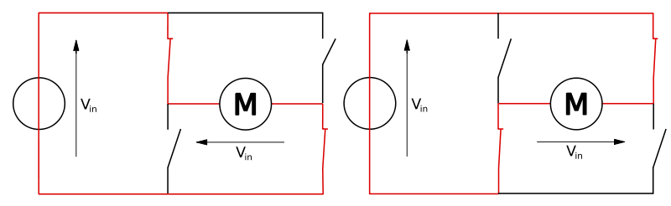
Fig 4.2.2 Operational diagram of H-Bridge inverter
Using the nomenclature above, the switches S1 and S2 should never be closed at the same time, as this would cause a short circuit on the input voltage source. The same applies to the switches S3 and S4. This condition is known as shoot-through.
The H-bridge arrangement is generally used to reverse the polarity of the motor, but can also be used to 'brake' the motor, where the motor comes to a sudden stop, as the motor's terminals are shorted, or to let the motor 'free run' to a stop, as the motor is effectively disconnected from the circuit.
The following table summarises operation, with S1-S4 corresponding to the diagram 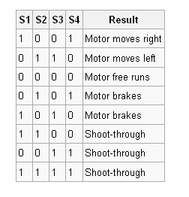
Table4.1: switching operation of H-bridge Inverter
The arrangement is sometimes known as a single-phase bridge inverter. The H bridge with a DC supply will generate a square wave voltage waveform across the load.
4.2.3 Advantages of H-bridge Inverters
The number of positive output voltage levels is more than twice the number of D.C.sources.
4.2.4. Disadvantages of H-Bridge Inverters
- Separate D.C. Sources are required for each of the H-bridges.

4.2.5 Single phase full bridge inverter
4.2.5.1 circuit diagram
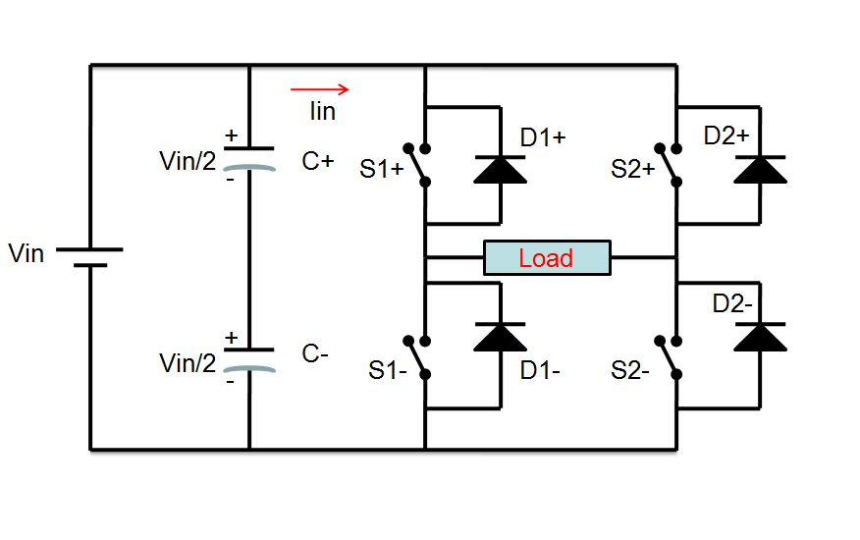
Fig4.2.5.1: single phase full bridge inverter

4.2.6 Operation
The full-bridge inverter is similar to the half bridge-inverter, but it has an additional leg to connect the neutral point to the load. Figure 4 shows the circuit schematic of the single-phase voltage source full-bridge inverter.
To avoid shorting out the voltage source, S1+ and S1- cannot be on at the same time, and S2+ and S2- also cannot be on at the same time. Any modulating technique used for the full-bridge configuration should have either the top or the bottom switch of each leg on at any given time.
Due to the extra leg, the maximum amplitude of the output waveform is Vi, and is twice as large as the maximum achievable output amplitude for the half-bridge configuration.States 1 and 2 from Table 2 are used to generate the AC output voltage with bipolar SPWM. The AC output voltage can take on only two values, either Vi or –Vi. To generate these same states using a half-bridge configuration, a carrier based technique can be used.
S+ being on for the half-bridge corresponds to S1+ and S2- being on for the full-bridge. Similarly, S- being on for the half-bridge corresponds to S1- and S2+ being on for the full bridge. The output voltage for this modulation technique is more or less sinusoidal, with a fundamental component that has an amplitude in the linear region of ma less than or equal to onev_{o1} =v_{ab1}= v_{i} • m_{a}.
Unlike the bipolar PWM technique, the unipolar approach uses states 1, 2, 3 and 4 from Table 2 to generate its AC output voltage. Therefore, the AC output voltage can take on the values Vi, 0 or –V [1]i. To generate these states, two sinusoidal modulating signals, Vc and –Vc, are needed, as seen in Figure 4.
Vc is used to generate VaN, while –Vc is used to generate VbN. The following relationship is called unipolar carrier-based SPWM v_{o1} =2 • v_{aN1}= v_{i} • m_{a}.
The phase voltages VaN and VbN are identical, but 180 degrees out of phase with each other. The output voltage is equal to the difference of the two phase voltages, and do not contain any even harmonics. Therefore, if mf is taken, even the AC output voltage harmonics will appear at normalized odd frequencies, fh.
These frequencies are centered on double the value of the normalized carrier frequency. This particular feature allows for smaller filtering components when trying to obtain a higher quality output waveform.As was the case for thehalf-bridge SHE, the AC output voltage contains no even harmonics due to its odd half and odd quarter wave symmetry.

4.2.7 Waveforms

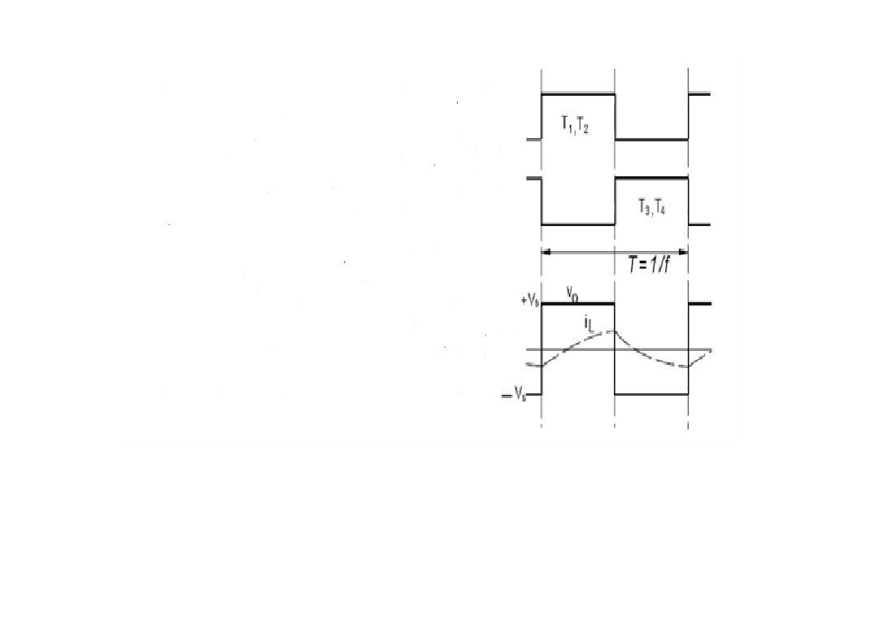
Fig:4.7 wave forms

This is the output voltage waveform for singlephase full bridge inverter during forward bias and reverse bias conditions

4.3 PULSE AMPLITUDE MODULATION
4.3.1 PWM Modulation
A novel PWM modulation technique was introduced togenerate the PWM switching signals. Three reference signals(Vref1, Vref2, and Vref3) were compared with a carrier signal(Vcarrier). The reference signals had the same frequency andamplitude and were in phase with an offset value that wasequivalent to the amplitude of the carrier signal. The referencesignals were each compared with the carrier signal. If Vref1had exceeded the peak amplitude of Vcarrier, Vref2 was compared with Vcarrier until it had exceeded the peak amplitude of Vcarrier. Then, onward, Vref3 would take charge and would be compared with Vcarrier until it reached zero. Once Vref3 hadreached zero, Vref2 would be compared until it reached zero.
Then, onward, Vref1 would be compared with Vcarrier. Fig. 3shows the resulting switching pattern. Switches S1, S3, S5,and S6 would be switching at the rate of the carrier signalfrequency, whereas S2 and S4 would operate at a frequency thatwas equivalent to the fundamental frequency.For one cycle of the fundamental frequency, the proposedinverter operated through six modes. Fig. 4 shows the per unit output-voltage signal for one cycle. The six modes aredescribed as follows:
Mode 1 : 0 <ωt< θ1 and θ4 <ωt< π
Mode 2 :θ1 <ωt< θ2 and θ3 <ωt< θ4
Mode 3 :θ2 <ωt< θ3
Mode 4 :π <ωt< θ5 and θ8 <ωt<2π
Mode 5 :θ5 <ωt< θ6 and θ7 <ωt< θ8
Mode 6 :θ6 <ωt< θ7.
Fig.4.3.1. Seven-level output voltage (Vab) and switching angles
The phase angle depends on modulation index Ma. Theoretically,for a single reference signal and a single carrier signal,the modulation index is defined to be
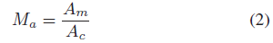
while for a single-reference signal and a dual carrier signal, themodulation index

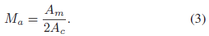
Since the proposed seven-level PWM inverter utilizes threecarrier signals, the modulation index is defined to be
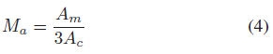
whereAc is the peak-to-peak value of the carrier signal and Amis the peak value of the voltage reference signal Vref .When the modulation index is less than 0.33, the phase angledisplacement is
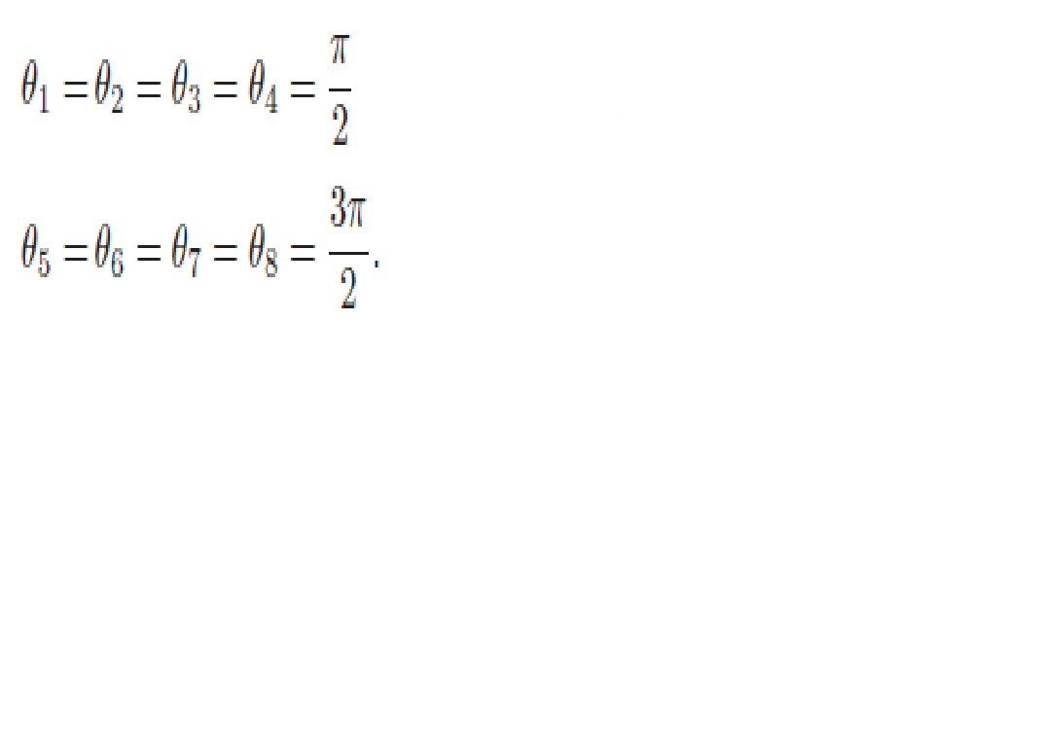
On the other hand, when the modulation index is more than0.33 and less than 0.66, the phase angle displacement isdetermined by
If the modulation index is more than 0.66, the phase angledisplacement is determined by

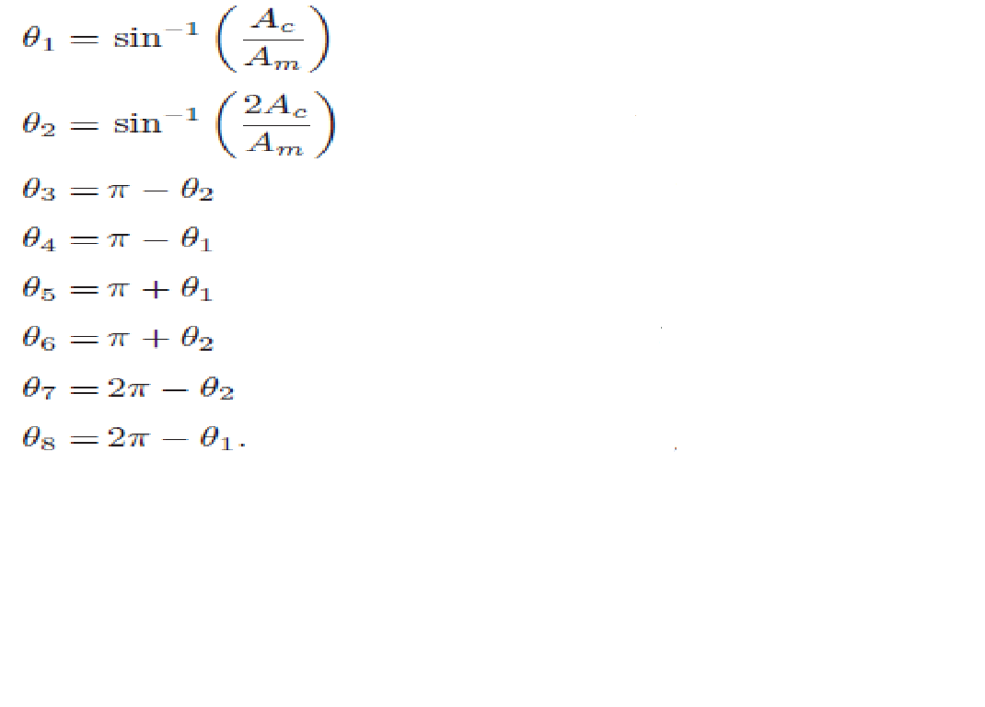
For Ma that is equal to, or less than, 0.33, only the lowerreference wave (Vref3) is compared with the triangular carriersignal. The inverter’s behavior is similar to that of aconventional full-bridge three-level PWM inverter. However,if Ma is more than 0.33 and less than 0.66, only Vref2 andVref3 reference signals are compared with the triangular carrierwave. The output voltage consists of five dc-voltage levels. Themodulation index is set to be more than 0.66 for seven levelsof output voltage to be produced. Three reference signals haveto be compared with the triangular carrier signal to produceswitching signals for the switches

4.3.2 PULSE WIDTH MODULATION
4.3.2.1 Two-Level PWM
The most common and popular technique of digital pure-sine wave generation is pulse-width-modulation (PWM). The PWM technique involves generation of a digital waveform, for which the duty-cycle is modulated such that the average voltage of the waveform corresponds to a pure sine wave. The simplest way of producing the PWM signal is through comparison of a low-power reference sine wave with a triangle wave (figure 7). Using these two signals as input to a comparator, the output will be a 2-level PWM signal (figure 8). This PWM signal can then be used to control switches connected to a high-voltage bus, which will replicate this signal at the appropriate voltage. Put through an LC filter, this PWM signal will clean up into a close approximation of a sine wave (figure 10). Though this technique produces a much cleaner source of AC power than either the square or modified sine waves, the frequency analysis shows that the primary harmonic is still truncated, and there is a relatively high amount of higher level harmonics in the signal
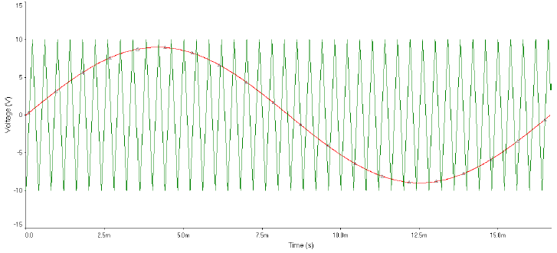
Figure4.3.2.1: 2-Level PWM Comparison Signals
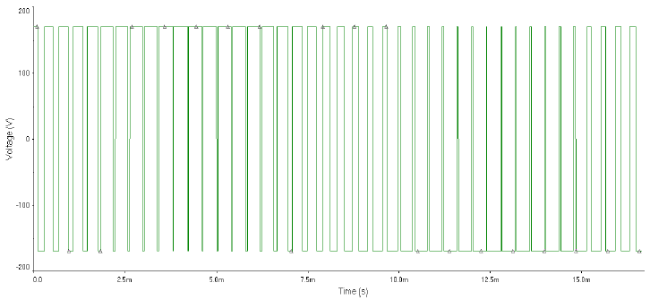
Figure 4.3.2.2: 2-Level PWM Output (Unfiltered)
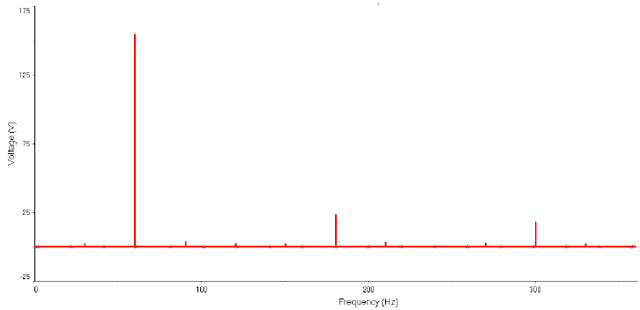
Figure 4.3.2.3: 2-Level PWM Harmonic Analysis
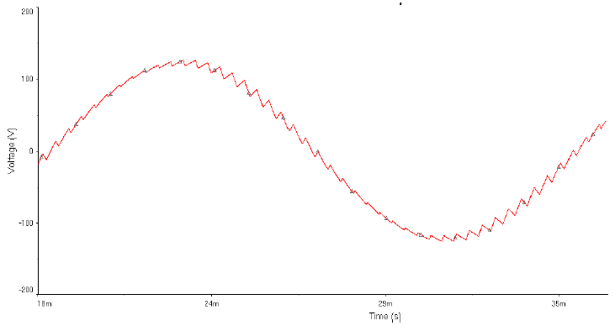
Figure 4.3.2.4: 2-Level PWM Output (Filtered)
4.3.3.Three-Level PWM

In order to create a signal which is closer to a true sine wave, a 3 level PWM signal can be generated with high, low, and zero voltage levels. For the resulting 3-level PWM signal to correspond to a sine wave, the signal comparison stage must also be 3-level (figure 11). A triangle wave is used as it is in the 2-level PWM comparison, but it half the amplitude and summed with a square wave to compare one half of the sine reference signal at a time. The resulting PWM signal is used to control one half of an H-bridge (figure 12), which controls how long the bus voltage is allowed through to the load. The other half of the H-bridge controls the polarity of the voltage across the load, and is controlled by a simple square wave of the same frequency and in phase with the sine signal. Generally, this square wave can simply be created in a stage of the sine wave generation circuit. A virtual example of such a 3-level circuit we simulated is shown in figure 12. The resulting 3-level high-voltage PWM signal (figure 13) can be filtered into a very close approximation of the desired sine wave (figure 14). It should be noted that the simulations we did for this technique utilized a very low switching frequency for the triangle wave, so the PWM switching frequency is also low. This was done so that the waveforms would be easy to view and understand. In reality, a switching frequency above 20 kHz would be used to keep inductance ringing outside the range of human hearing.
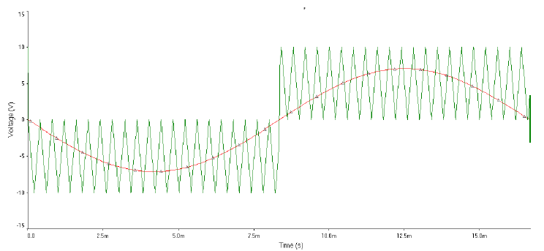
Figure 4.3.3: 3-Level PWM Comparison Control Signals
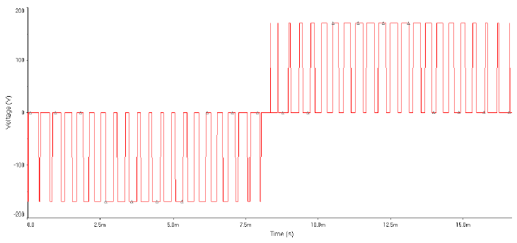
Figure 4.3.4: Simulated 3-Level PWM Output (Unfiltered)
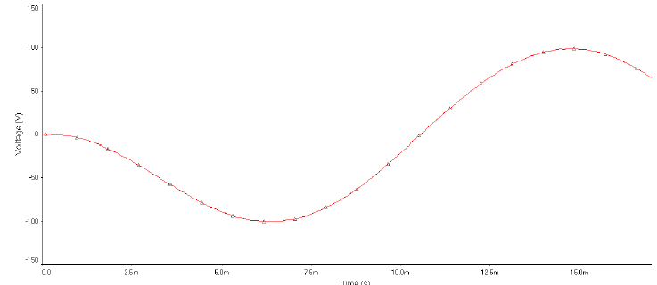
Figure 4.3.3: Simulated 3-Level PWM Output (Filtered)
Figure4.3.4: 3-Level PWM Harmonics Analysis of Unfiltered Output
The 3-Level PWM frequency plot shown in figure 4.8 markedly improved over those of the square and modified sine techniques. The primary frequency of 60Hz is the dominant in all three, but the magnitude of the harmonic frequencies is much reduced in 3-Level PWM, and the primary is of larger magnitude. When compared to the 2-level PWM, however, a couple things are noticed. First, the harmonics plot shows no higher level harmonics of significant magnitude. This represents the 3-Level signal following much more closely the desired sine wave. However, the primary frequency has a much lower voltage magnitude than that of the 2-Level design. The reason for this is the presence of other frequencies which are not harmonics of the 60Hz signal, which are caused by the switching of the signal from one polarity to the other, and back.
4.3.4 Five-Level PWM
In order to create a PWM signal which more closely follows the desired sine wave output, the design described for the 3-level PWM technique can be expanded to 5-, 7- and 9+ level PWM. Each additional 2 levels added on top of the 3-level design adds an H-bridge (added in series), a comparator, and a summer. The added accuracy of the signal due to increasing the level therefore brings with it the addition of components, and the space, cooling, and power they require. Control signals must be created separately for each H-bridge (figure 18), each of which correspond to one layer of the sine voltage (figure 19). Higher level PWM also requires multiple isolated voltage buses. For example, the 5-level PWM circuit in figure 17 requires two isolated buses at 1/2 the voltage of the corresponding 3-level circuit. The buses must be isolated, as they need to be connected in series. In the 5-level PWM circuit, one half of each H-bridge is controlled by the square wave from the 3-level circuit, and simply controls polarity across the bridge. The other half of each bridge is controlled by the PWM output of each respective comparator. The resulting PWM signal is shown in figure 20, and the filtered sine wave output is shown in figure 21. One of the advantages of higher level PWM generation is that there is less of a voltage swing from the minimum and maximum of each step, which results in less power loss due to the slope up and down for each step (known as dV/dt losses). This reduced power loss results in higher efficiency for the inverter. This increased efficiency must be considered in balance with the addition of components and frequency effects which must be filtered out.
The frequency plot of the 5-level PWM technique can be seen to be improved over that of the 3-level scheme (figure 22). The harmonic frequencies are reduced, as in the 3-level technique, but the magnitude of the primary is significantly larger. Note that these plots show only harmonics of the 60Hz primary, and thus do not show the effects of the switching frequencies. The improvement of the 5-level PWM can, however, still be seen in the difference of the primary frequency's magnitude
Figure 4..3.4.1: 5-Level PWM Comparison Signals
Figure 4.3.4.2m: PWM Bridge Control Signals (superimposed)
Figure4.3.4.3: 5-Level PWM Output (unfiltered)
Figure4.3.4.4: 5-Level PWM Output (filtered)
Figure 4.3.4.5: 5-Level PWM Harmonics Analysis of Unfiltered Output
4.3.5 Amplitude Modulation
In PWM generation, two very important characteristics are ma and mf, where mf is the ratio between the frequency of the triangle wave to the sine wave signal, and is generally an odd integer. This number is significant in that it determines the frequency of the harmonics in the PWM output signal. The significant components of this output are the primary, the harmonic at frequency mf*fc where fc is the frequency of the sine wave control (as well as the primary output), and the harmonics at mf+2*fc and mf-2*fc. Mf, therefore, determines the frequency of the harmonics of the output, which of course affects how easily they can be filtered out.
Ma is the ratio of the amplitudes of the sine wave and the triangle wave, and is always kept between 0 and 1, as a value above 1 will result in clipping and non-linear amplitude relationships. Between 0 and 1, though, the amplitude of the primary is linearly related to ma. As the ma ratio decreases, the amplitude of the primary also decreases. At the same time, though, the amplitude of the harmonics increase, and the mf harmonic actually becomes larger than the primary just above 0.8 ma.
Table 4.3.5.1: Normalized Fourier Coefficients6
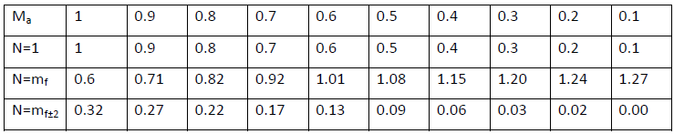
In an unfiltered output, this can be very bad, especially if the load is not inductive. If there is a large inductive component, though, this will act as a low-pass filter, as the impedance will be very large as long as your triangle wave's frequency is also very high, since ZL=ωL. This can be further resolved by filtering your output with an added low-pass filter.
In order to test the bipolar PWM, we created two test circuits. The first is a virtual bipolar PWM circuit with an H-Bridge, which was operated with a bus voltage of 100V (the figure shows the configuration for the fourier comparison, i.e. 2V bus). The triangle wave signal was 2V in amplitude with a frequency of 20kHz. The sine wave signal was held at a constant 60Hz, but the amplitude was varied from 0.1414 to 1.3435 Vrms to vary the ma of the system from 0.1 to 0.95. The filtered waveform at each value was then displayed. The individual waveforms were then combined into one graph for easy comparison. It should be noted that the magnitude of the waves decreased as ma was decreased, but the wave-forms on the graph are normalized to magnitude, to show only the distortion present in the filtered output.
Figure 4.3.5.1.: Filtered Outputs ma 0.1 to 0.95
There is no significant distortion of the filtered output even at very low values of ma. There is some distortion at 0.3, 0.2, and 0.1, but it is not overwhelmingly large. The main downside of a low ma, then, is the additional power loss of the harmonics in the filter. Because the impedance of the inductor in the filter becomes much higher at the harmonic frequencies, though, the currents involved in these losses are small.

5 .SIMULATION
5.1Block diagram of proposed circuit

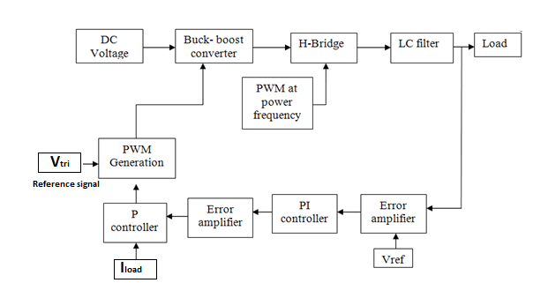
Fig5.1:Block diagram of proposed Buck-Boost single phase VSI for Distribution Generation system

6.MATLAB SIMULATION
6.1 MATLAB CICUIT FOR PROPOSED CIRCUIT
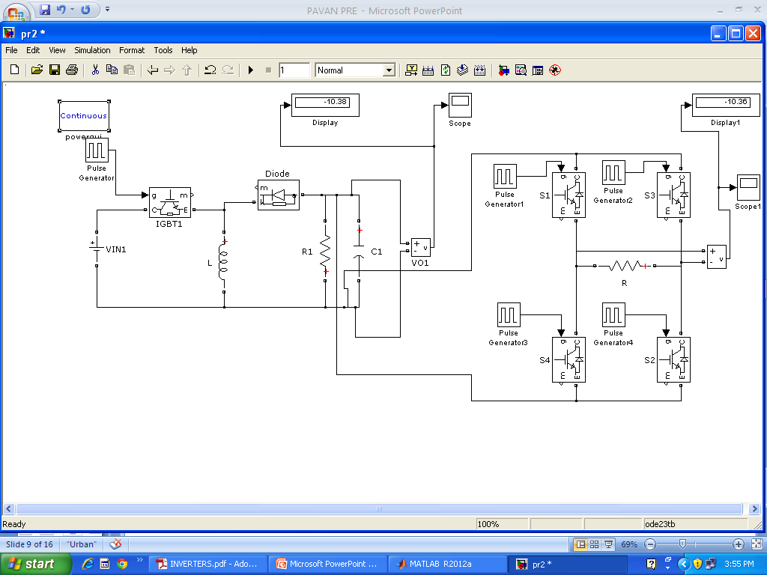

7. RESULTS
BUCK-BOOST CONVERTER OUTPUT

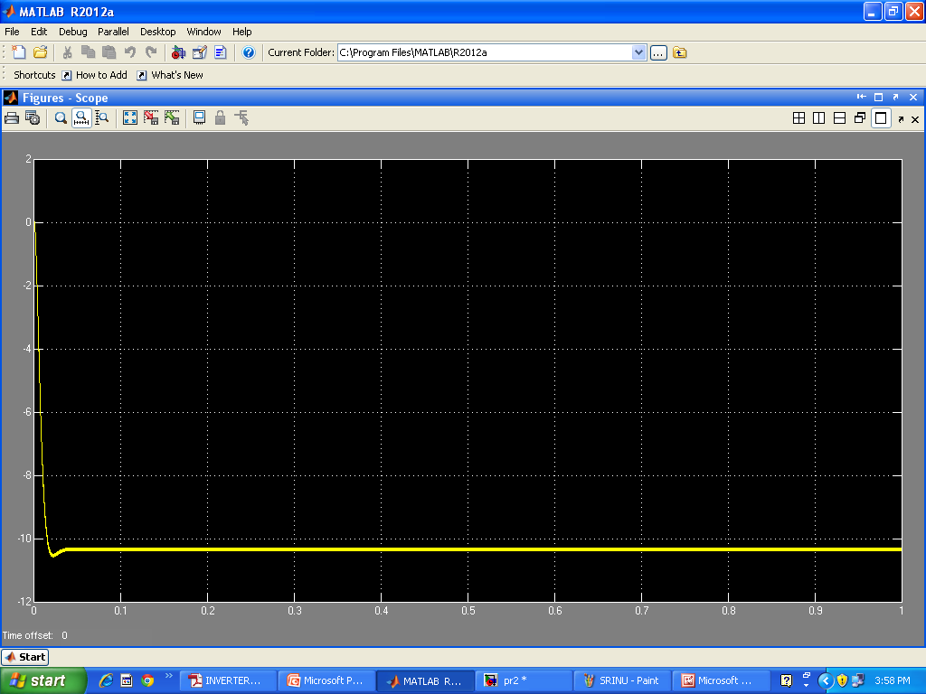

SINGLE PHASE VOLTAGE SOURCE INVERTER OUTPUT
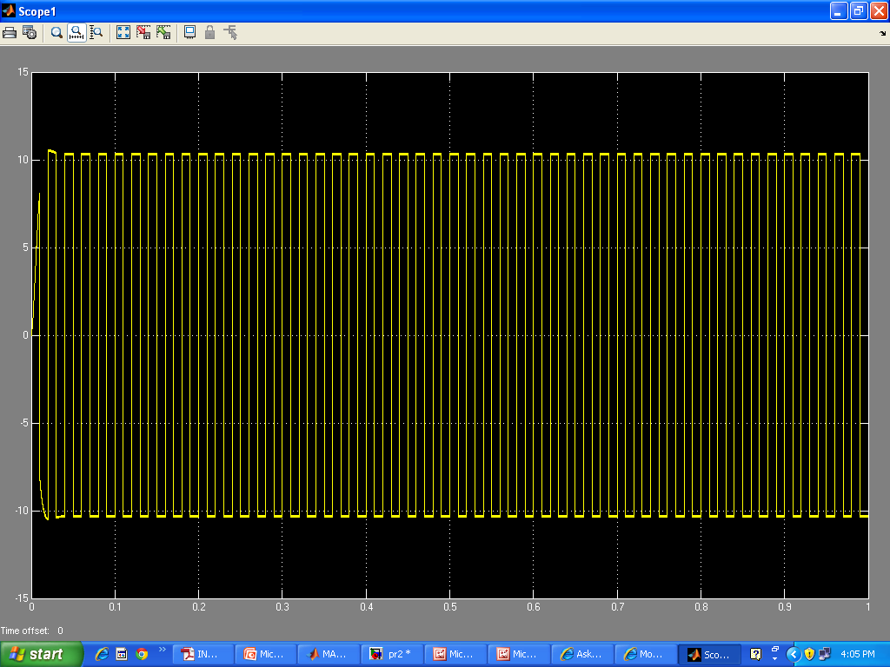

8. CONCLUSION
Simulation of unidirectional of buck- boost single phase voltage source inverter has been carried out using MATLAB simulink software package. From simulation results it is seen the proposed topology of buck-boost single phase voltage inverter works exceptionally well producing an ac square wave output depending upon the input to the buck-boost converter.
From simulation results it can seen that the voltage source buck-boost inverter either bucks or boost the input voltage.
The proposed inverter is applicable as a utility interactive inverter for distributed generating systems and harmonic elimination applications. The proposed inverter uses six switches. The low switching frequency of the output H-bridge reduces inverter switching losses and costs, compared to six and eight switch-based techniques.

REFERENCES
[1] T. G.Wilson, “The evolution of power electronics,” IEEE Trans. Power Electron., vol. 15, pp. 439–446, May 2000.
[2] X. Yaosuo, C. Liuchen, B. K. Kjaer, J. Bordonau, and T. Shimizu, “Topologies of single-phase inverters for small distributed power generators: An overview,” IEEE Trans. Power Electron., vol. 19, no. 5, pp. 1305–1314,Sep. 2004.
[3] R. Gonzalez, E. Gubia, J. Lopez, and L.Marroyo, “Transformerless single phase multilevel-based photovoltaic inverter,” IEEE Trans. Ind. Electron., vol. 55, no. 7, pp. 2694–270.
[4] Ahmed Mohamed Salamah, Stephen J. Finney “Single- Phase Voltage Source Inverter with a Bidirectional Buck– Boost Stage for Harmonic Injection and Distributed Generation” IEEE transactions on power electronics, vol. 24, no. 2, pp 376- 387, February 2009.
[5] Roman, I.T. “A single-phase current-source inverter with active power filter for grid-tied PV systems”, 3rd IEEE International Symposium on Power Electronics for Distributed Generation Systems (PEDG), Aalborg, pp. 349-356, June 2012.
[6] T. Boutot and L. Chang, “Development of a single-phase inverter for small wind turbines,” in Proc. IEEE Elect. Comput. Eng. Can. Conf. (CCECE 1998), Waterloo, ON, Canada, May 24–28, pp. 305–308.
[7] P. Lezana, J. Rodrıguez, and D. A. Oyarzun, “Cascaded multilevel inverter with regeneration capability and reduced number of switches,” IEEE Trans. Ind. Electron., vol. 55, no. 3, pp. 697–703, Mar. 2008.
[8] Yan Zhang “Comparison of traditional two-stage buck- boost voltage source inverter and diode-assisted buck-boost voltage source inverter” Twenty-Seventh Annual IEEE trans on Applied Power Electronics Conference and Exposition (APEC), Orlando, FL, pp 141-148, Feb 2012.
[9] Samuel, P. “Grid Interface of Wind Power With Large Split-Winding Alternator Using Cascaded Multilevel Inverter” IEEE Transactions on Energy Conversion, Volume: 26, Issue: 1, pp 299-309, March 2011.
[10] Jalbrzykowski, S, Citko, T. “Current-Fed Resonant Full- Bridge Boost DC/AC/DC Converter” IEEE Transactions on Industrial Electronics, Volume: 55, Issue:3, pp 1198 – 1205, March 2008. single phase multilevel-based photovoltaic inverter,” IEEE Trans. Ind. Electron., vol. 55, no. 7, pp. 2694–2702, Jul. 2008.
[4] Ahmed Mohamed Salamah, Stephen J. Finney “Single- Phase Voltage Source Inverter with a Bidirectional Buck– Boost Stage for Harmonic Injection and Distributed Generation” IEEE transactions on power electronics, vol. 24, no. 2, pp 376- 387, February 2009.
[5] Roman, I.T. “A single-phase current-source inverter with active power filter for grid-tied PV systems”, 3rd IEEE International Symposium on Power Electronics for Distributed Generation Systems (PEDG), Aalborg, pp. 349-356, June 2012. [6] T. Boutot and L. Chang, “Development of a single-phase inverter for small wind turbines,” in Proc. IEEE Elect. Comput. Eng. Can. Conf. (CCECE 1998), Waterloo, ON, Canada, May 24–28, pp. 305–308.
[7] P. Lezana, J. Rodrıguez, and D. A. Oyarzun, “Cascaded multilevel inverter with regeneration capability and reduced number of switches,” IEEE Trans. Ind. Electron., vol. 55, no. 3, pp. 697–703, Mar. 2008.
[8] Yan Zhang “Comparison of traditional two-stage buck- boost voltage source inverter and diode-assisted buck-boost voltage source inverter” Twenty-Seventh Annual IEEE trans on Applied Power Electronics Conference and Exposition(APEC), Orlando, FL, pp 141-148, Feb 2012.
[9] Samuel, P. “Grid Interface of Wind Power With Large Split-Winding Alternator Using Cascaded Multilevel Inverter” IEEE Transactions on Energy Conversion, Volume: 26, Issue: 1, pp 299-309, March 2011.
[10] Jalbrzykowski, S, Citko, T. “Current-Fed Resonant Full- Bridge Boost DC/AC/DC Converter” IEEE Transactions on Industrial Electronics, Volume: 55, Issue:3, pp 1198 – 1205, March 2008.

